Gall Stone Ileus
Stem: A 76-year-old demented woman presents to the emergency department from her nursing facility with 4 days of intermittent abdominal pain, confusion, food intolerance, emesis and diminished urinary output.
Past medical history includes Alzheimer’s dementia, COPD, CAD, HTN, cholelithiasis, HLD.
Past surgical history includes total abdominal hysterectomy.
Examination: HR 110bpm, BP 106/43mmHg, 92% sats on room air, 36.6C. Abdomen is distended and tympanic however soft, with generalized tenderness without involuntary guarding or signs of peritonitis.

Pertinent labs: WBC of 12.4, LA 2.4, NA 130, Chloride 92. LFTs, lipase and amylase are within normal limits.

What study would you order?

- Abdominal xray
- CT scan

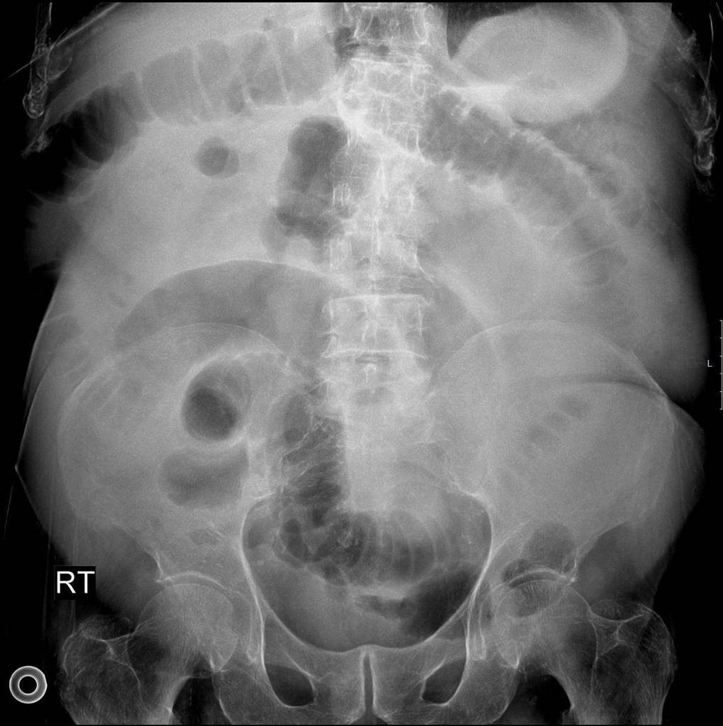

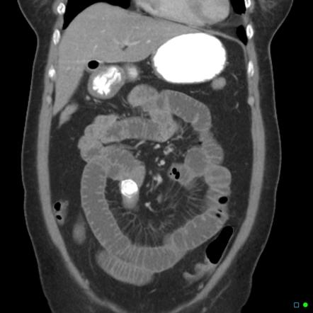

What is your differential diagnosis?
- Small bowel obstruction
- Gallstone ileus
- Mesenteric ischemia
- Intestinal perforation
- M alignancy

What would you like to do now?
- NGT decompression
- IV access
- Resuscitation.

Recognition of gallstone ileus on imaging
- OR for exploratory laparotomy
  - Inspect/palpate entire midgut
  - Longitudinal enterotomy, stone extraction and closure in Heineke-Mikulicz fashion

How do you mange cholecystoenteric fistula?
leave it alone in old, frail and sick people

Scenario 1: Same patient, however, you are unable to milk the stone out proximally.
Perform a segmental small bowel resection.
Scenario 2:Same patient successfully treated with enterotomy with stone retrieval and primary closure of the small bowel. In the coming days becomes increasingly tachycardic, febrile, and hypotensive.

What is your diagnosis? How would you manage
E nteric leak
- IVF resus citation.
- E mpiric abx.
- If stable CT
- Versus I mmediate return to OR

Scenario3: Gallstone ileus identified in a 60-year-old farmer with history of HTN and HLD, otherwise physically active and relatively healthy.
What would you do with the gallbladder and cholecystoenteric fistula in this setting?

- Explores gallbladder and identifies whether there are residual stones
- If patient is stable and can undergo long procedure would be acceptable to perform cholecystectomy and closure of cholecystoenteric fistula at time of surgery, otherwise perform as staged procedure.
- At time of cholecystectomy, performs cholangiogram to ensure CBD exploration does not need to be performed.

Describe how to repair the duodenum?
Debride edges if needed, assess posterior wall and ampulla, primary repair transversely to avoid stricture. Protection of repair: buttress with omental fat/falciform, serosal flap. JP drain.

Pitfalls:
- Not recognizing high risk of fistula take down in acute setting.
- Not p erform ing cholangiogram at time of surgery to rule out need for CBD exploration.
- Not knowing rule of fistula staged take down or at time of surgery IF appropriate.

